<https://www.sitepoint.com/getting-started-vagrant-windows/>

<https://github.com/Varying-Vagrant-Vagrants/VVV/wiki/Connect-to-Your-Vagrant-Virtual-Machine-with-PuTTY>

1. Have Virtual Box installed on Windows Machine
2. Download PuTTY
3. Download and Install Vagrant on Windows Machine
4. Once done, create a folder to initialize and create the VMs from Vagrant on the Windows Machine
5. Type “vagrant init (box-name, search vagrantcloud)”, it will mention that a vagrantfile has been placed in this directory
6. “vagrant up”, will spin up the testing environment using virtual box, it’ll download the VM that was initialized and generate credentials and forward ports that the user can SSH into from PuTTY
7. Get SSH configuration through “vagrant ssh-config”, connect through PuTTY – vagrant:vagrant
8. Go to user-profile -> .vagrant.d
9. PuTTYgen -> load up the insecure_private_key file, save private key
10. Go back into PuTTY -> Connection/SSH -> Browse and find .ppk private key
11. “vagrant destroy”, does not remove downloaded box file only closes the current session, “vagrant box remove” removes the box and will require a new “vagrant init”

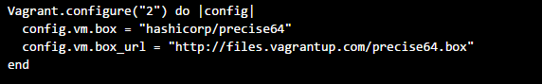

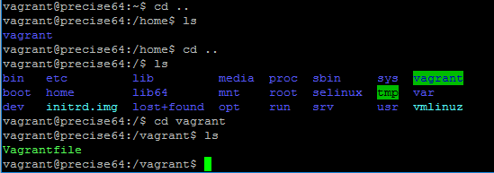

vagrant reload --provision

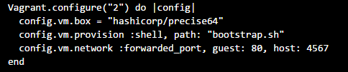

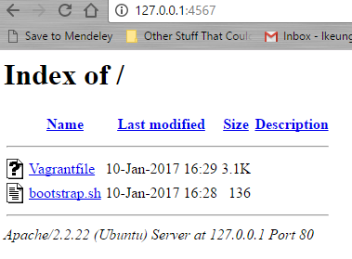

“vagrant suspend” -> “vagrant up” – very fast, saves running state and stops it. Eats up disk space and requires disk space to store RAM

“vagrant halt” -> “vagrant up”- cleanly shuts down machine, preserving contents of disk

“vagrant destroy” -> “vagrant up” – destroys trace of guest machine, shuts down, removes. No crust is left on machine